User Manual

1. Below is the login screen of the system.

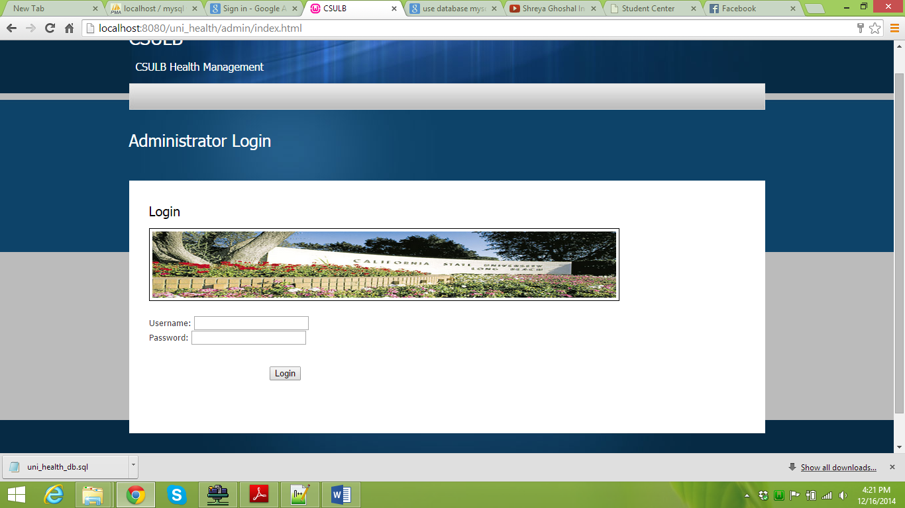

Username = m.karish14

Password = 123

1. The system has various tabs as :
2. Students List
3. Groups
4. Campaigns
5. Settings
6. Analysis
7. In the Students List tab, we can view the list of students who have scheduled appointments today and the next day. Please refer the diagram below:

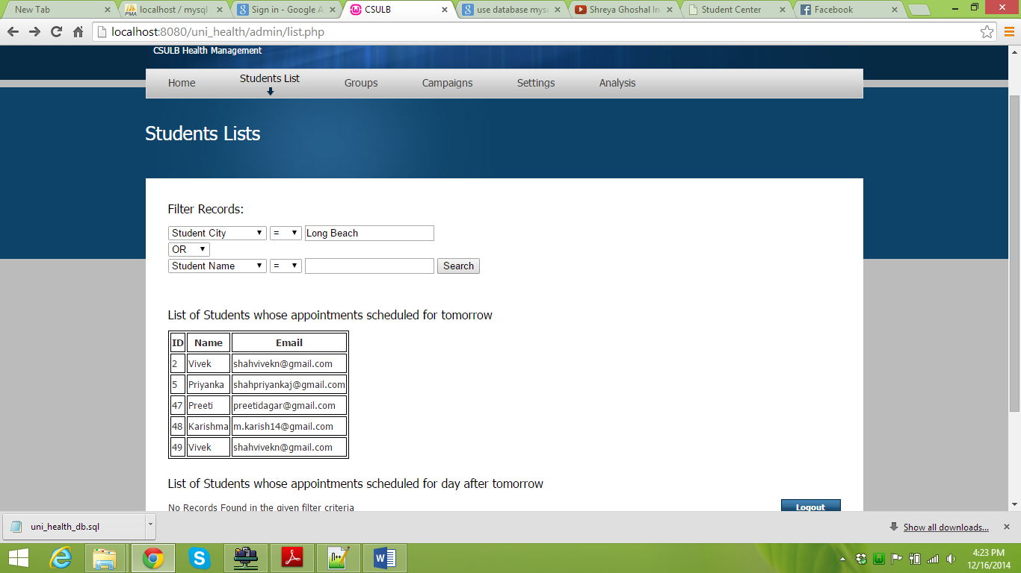

1. Saving the search list generated.

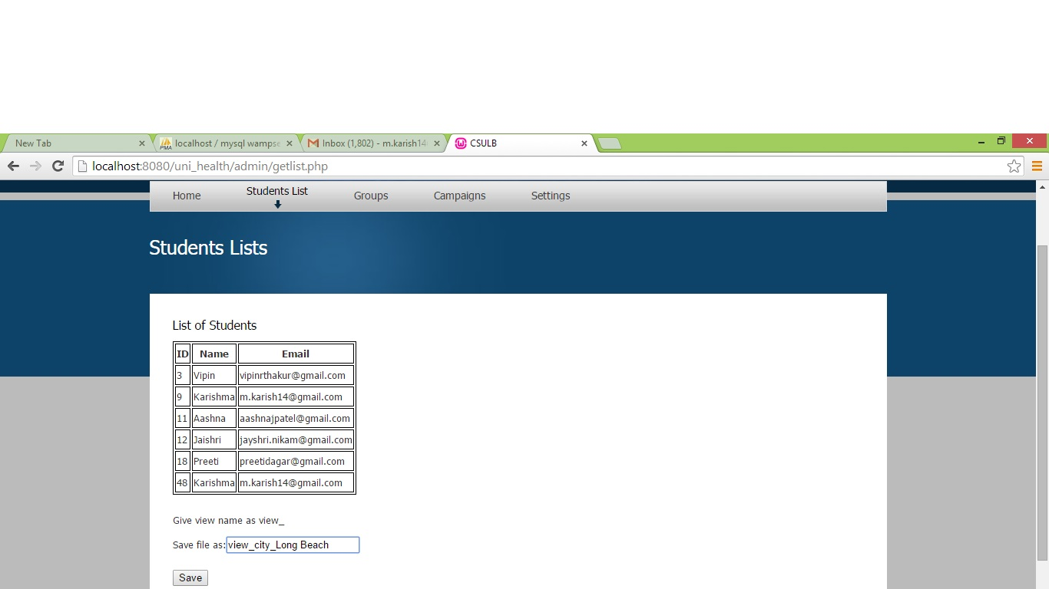

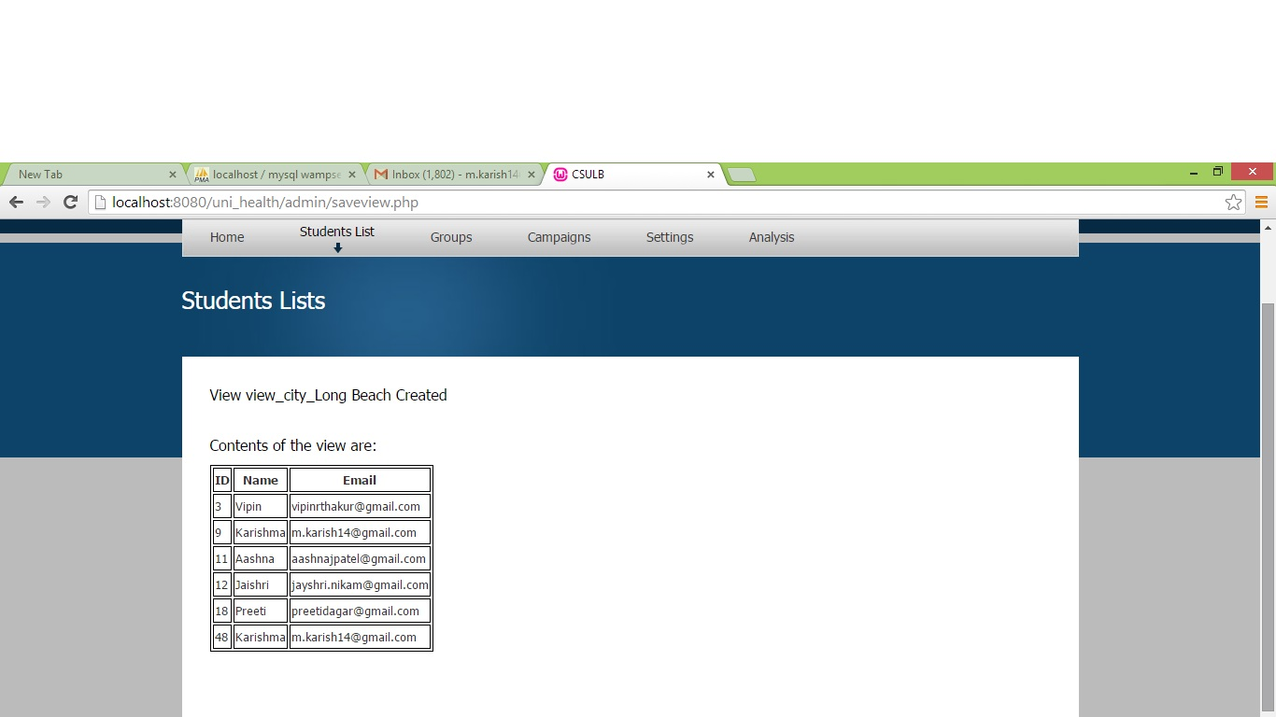

1. Created groups can be viewed under Groups tab

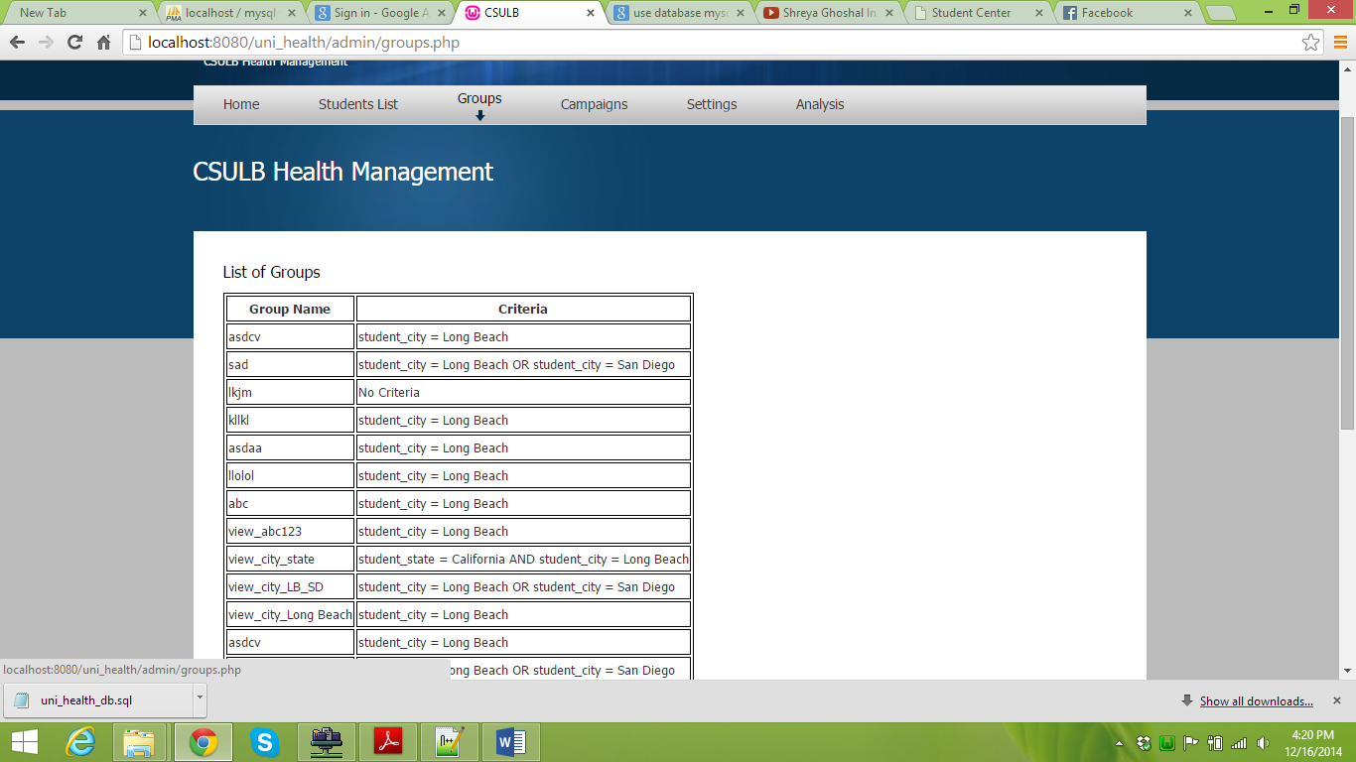

1. Campaigns Tab contains the actions to be performed on the list

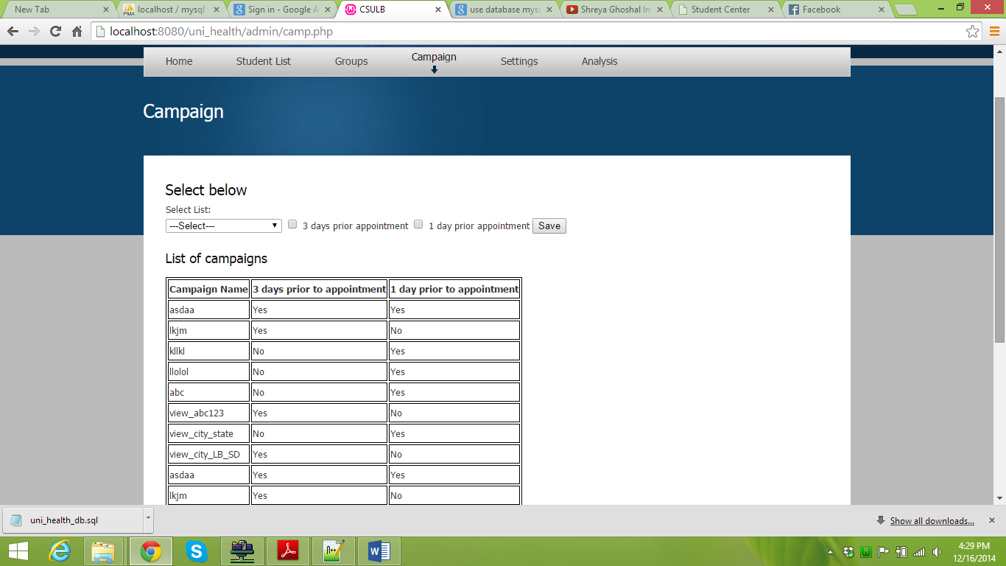

1. Settings has the Email template

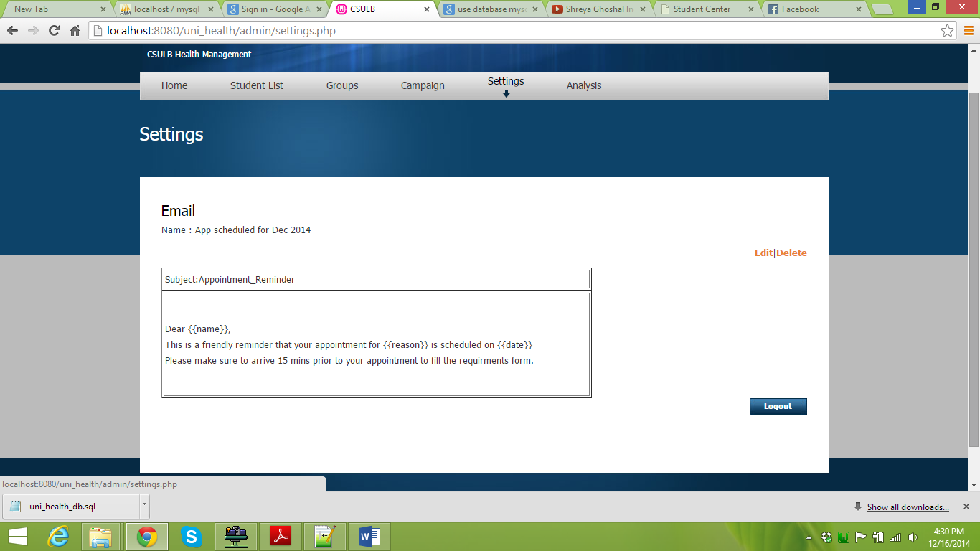

1. Clicking on edit we can customize the email template

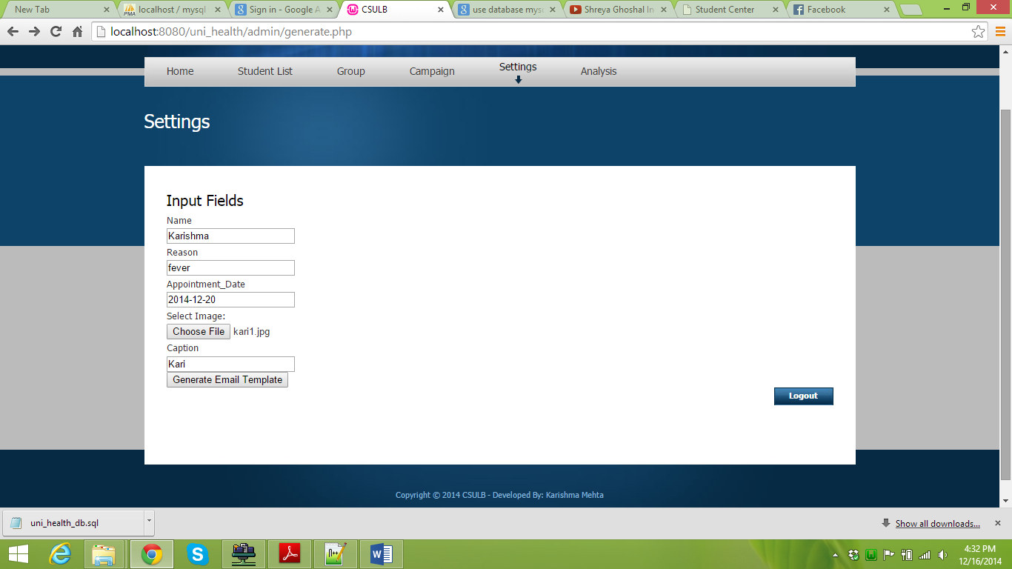

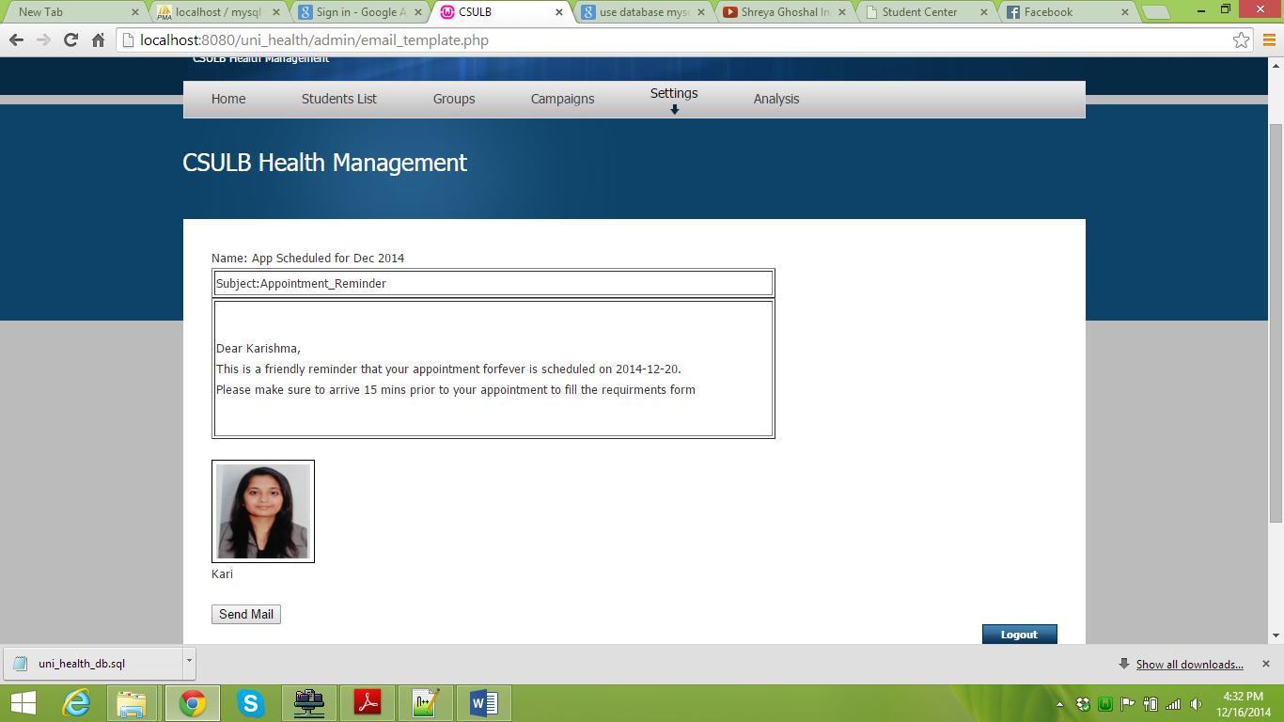

Email send are stored in the email_table and email_sent table

1. Send Mail option will then send email to ‘Karishma’

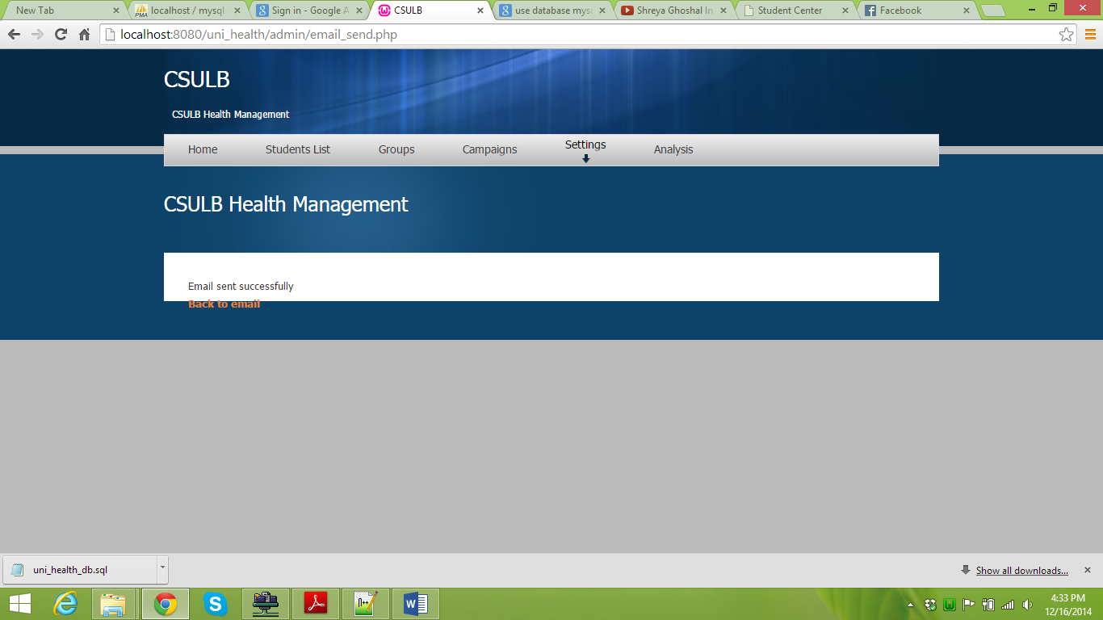

1. Email sent to email id [m.karish14@gmail.com](mailto:m.karish14@gmail.com)

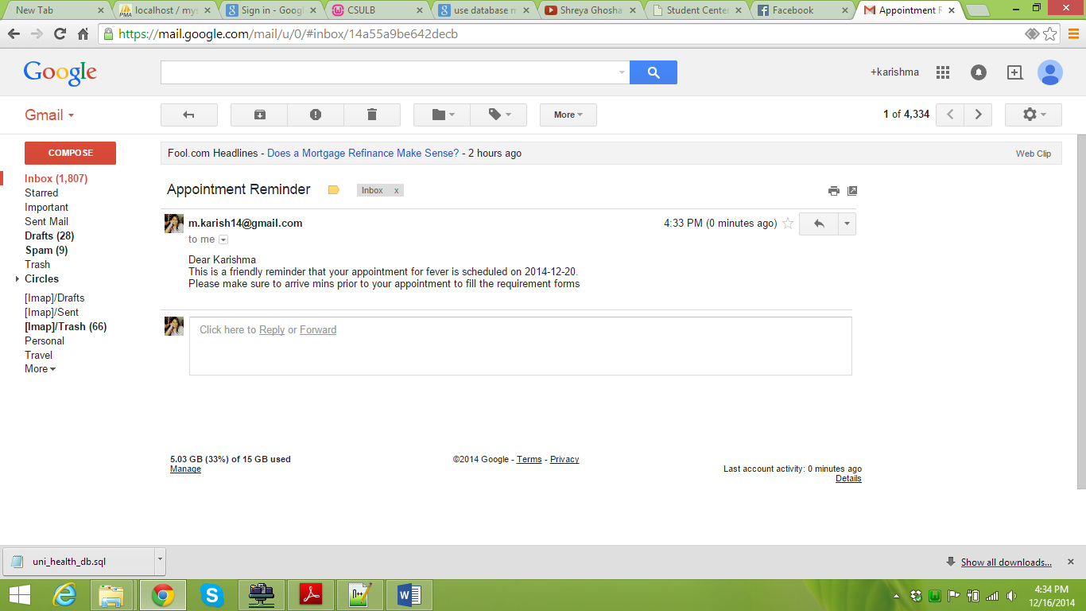

1. We can also delete the send mails from the delete link on the email_template

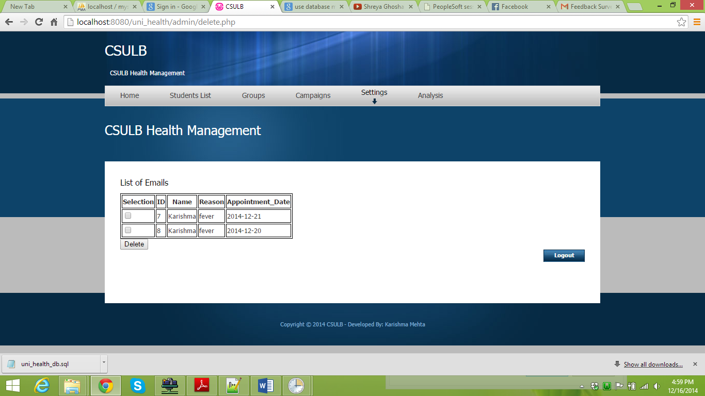

1. In the Analysis tab, we are performing analysis based on city, disease and name.

Based on city, it presents that how many percentage of students from a particular area have visited the health center

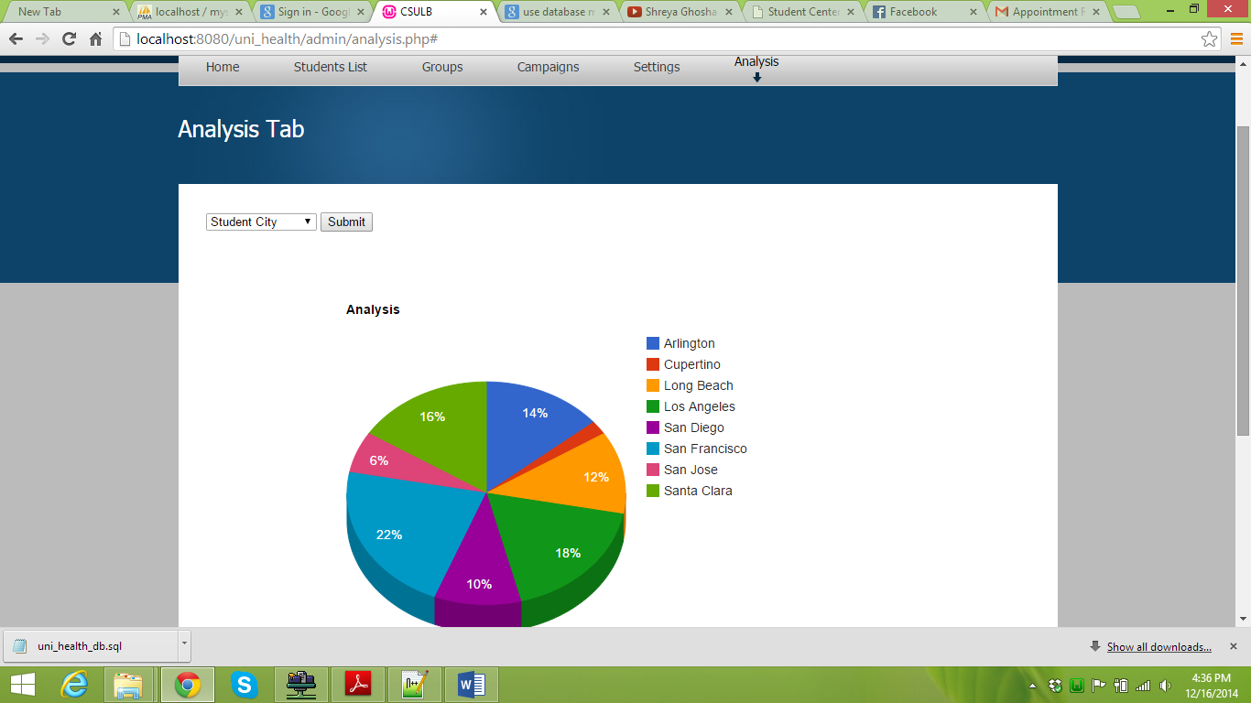

Based on the disease, we can analyze which disease is occurring more frequent in the city.

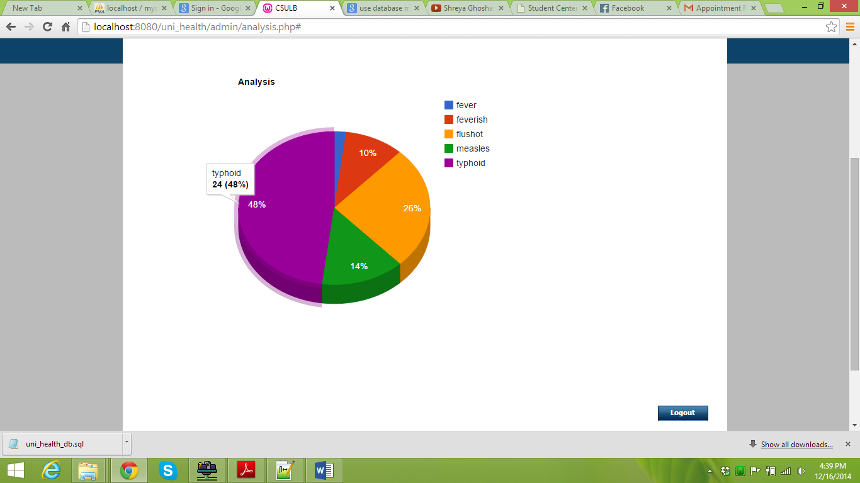

Based on the student name, we can analyze how frequent the student visits the health center

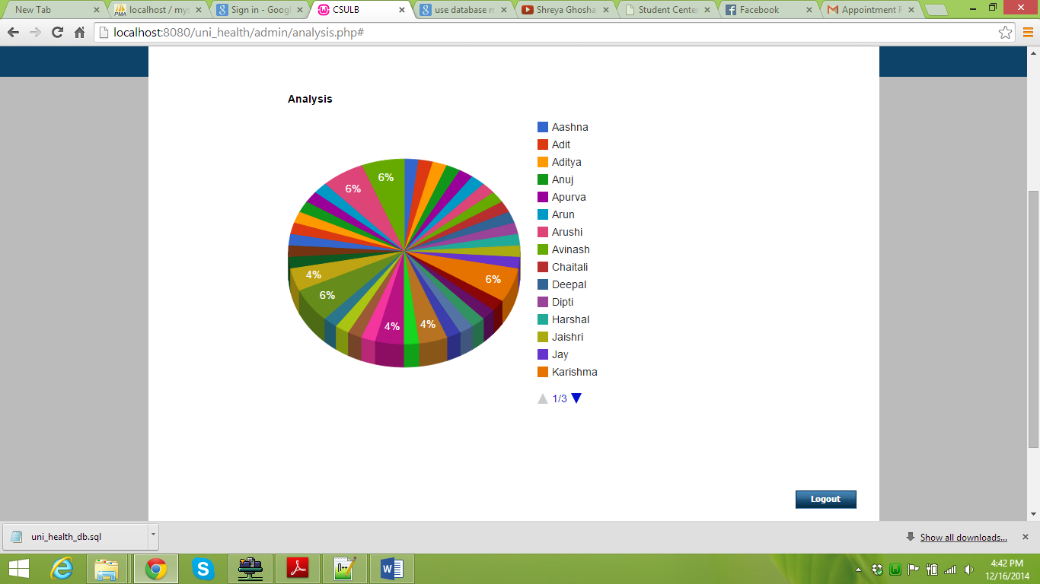

1. Task Scheduler Settings:

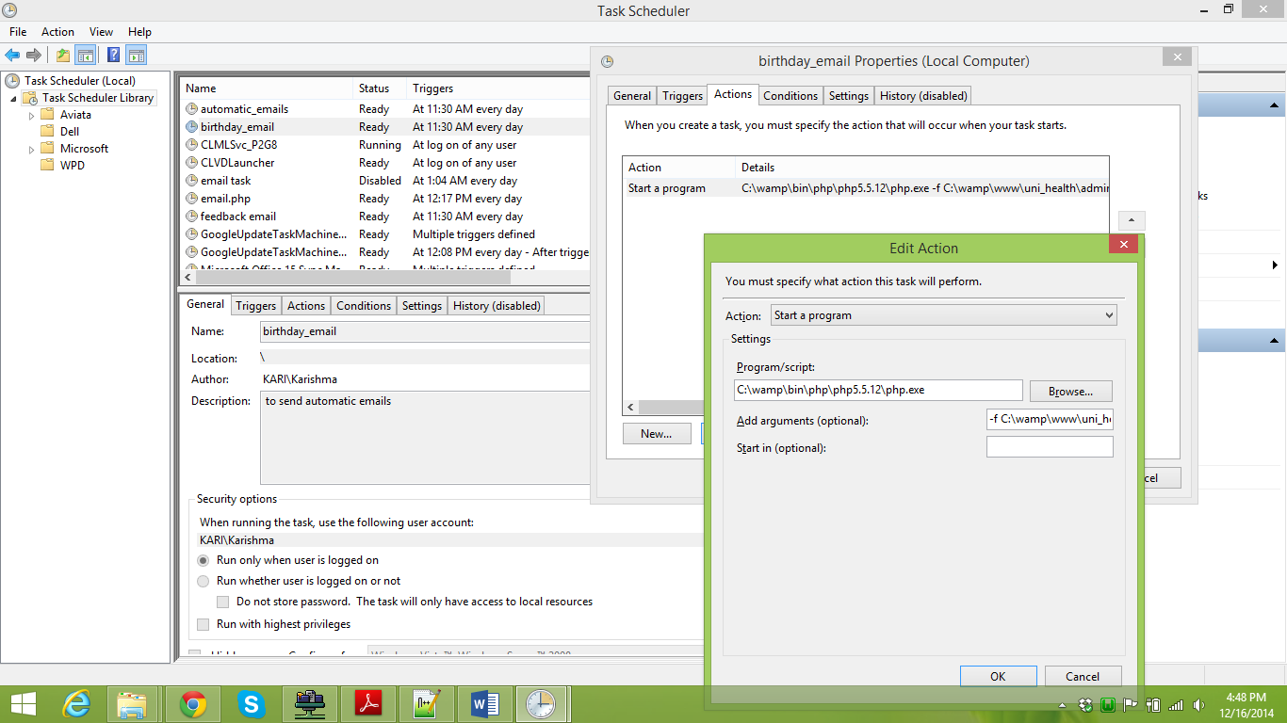

1. Students who have visited the health center are then asked to fill the feedback form

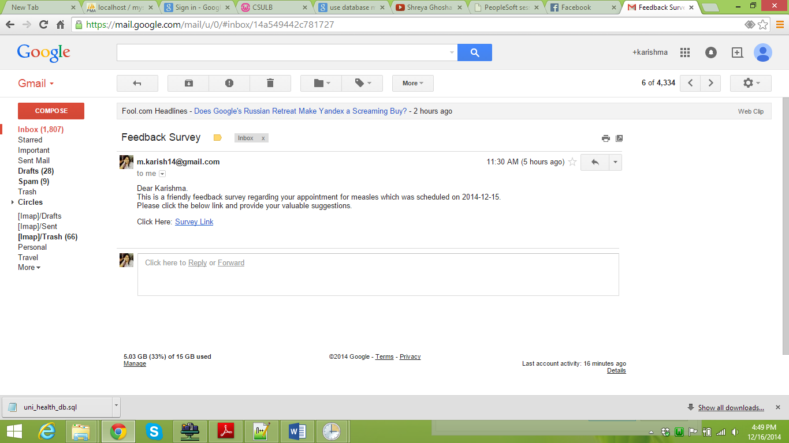

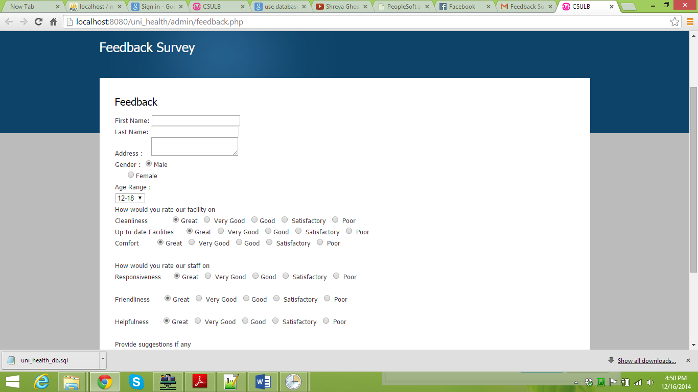

1. Below are the birthday emails and appointment reminder emails(1 day before and 3 days before)

